DynaMed Email Template

Directions for use: First copy and paste the suggested subject line into the subject line of your email. Next, copy the entire table below including the header, footer and graphics and paste it into the body of your email. Once you have pasted the table into the body of the email, you can “select all”, center the content, and make edits to the highlighted section toward the bottom to include information specific to your organization.

Suggested Subject Line: New Clinical Decision Support Tool - DynaMed Now Available



Now Available to {Name of Facility} Clinicians

DynaMed® - The Next Generation of Clinical Decision Support

DynaMed combines the highest quality evidence-based information, expert guidance and a user-friendly, personalized experience to deliver accurate answers fast at the point of care.



{Right click the button above and link it your organizations access point for DynaMed then delete this copy}

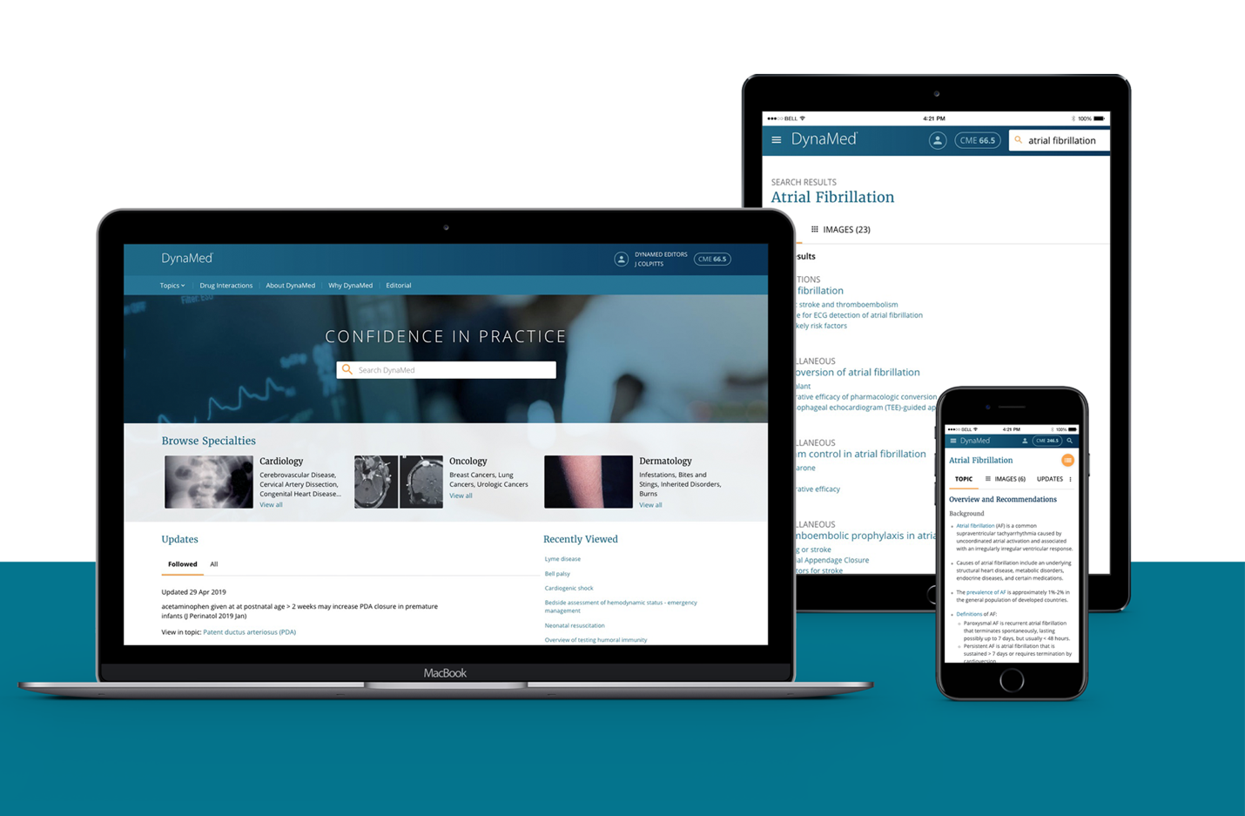
Why DynaMed?

  Ensures Confidence in Practice  Our content is created using a rigorous  evidence-based methodology, robust  systematic literature surveillance, and  clinical expertise that complements  and clarifies the evidence. |  |   Saves Time  Key takeaways, targeted synopses, and  clearly defined recommendations maximize efficiency, reducing time-to-answer with information that is quickly accessible  and actionable.
  Creates an Individual Experience  Your personal user account allows  DynaMed to remember your preferences and anticipate your interests getting you to the information that matters most to you fast. Seamless tracking of your DynaMed usage  allows you to earn CME and MOC for  all your activity. |  |   Anytime, Anywhere Access  DynaMed is fully integrated into your  workflow with features including EHR  integration, a convenient mobile app and  single sign-on capabilities.
DynaMed can be accessed from {Insert your access information here}.

For more information, please contact: {Insert Name and Contact Information}

dynamed.com | 

