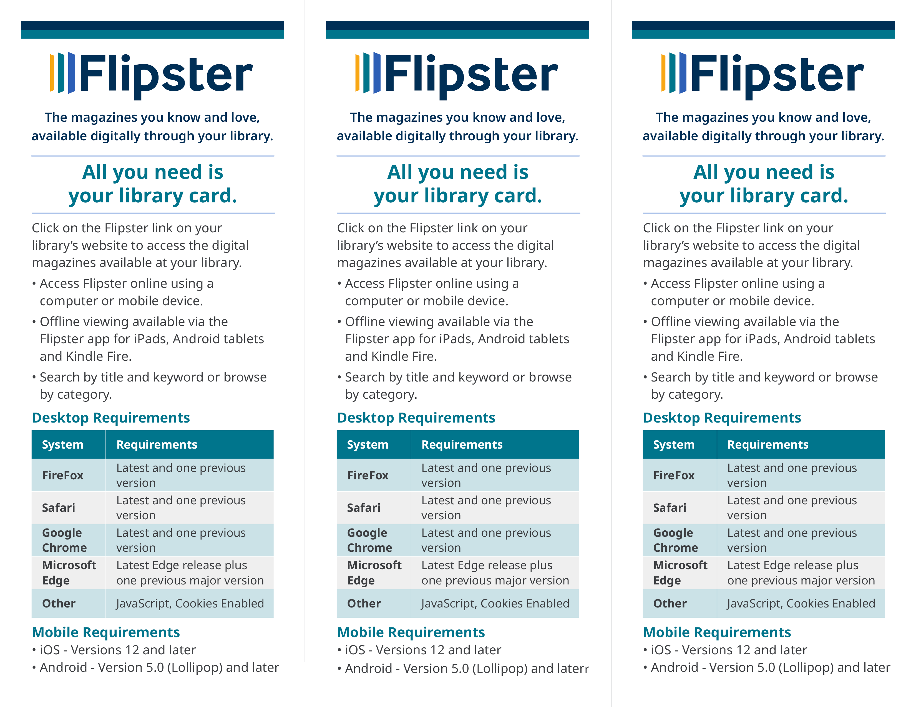
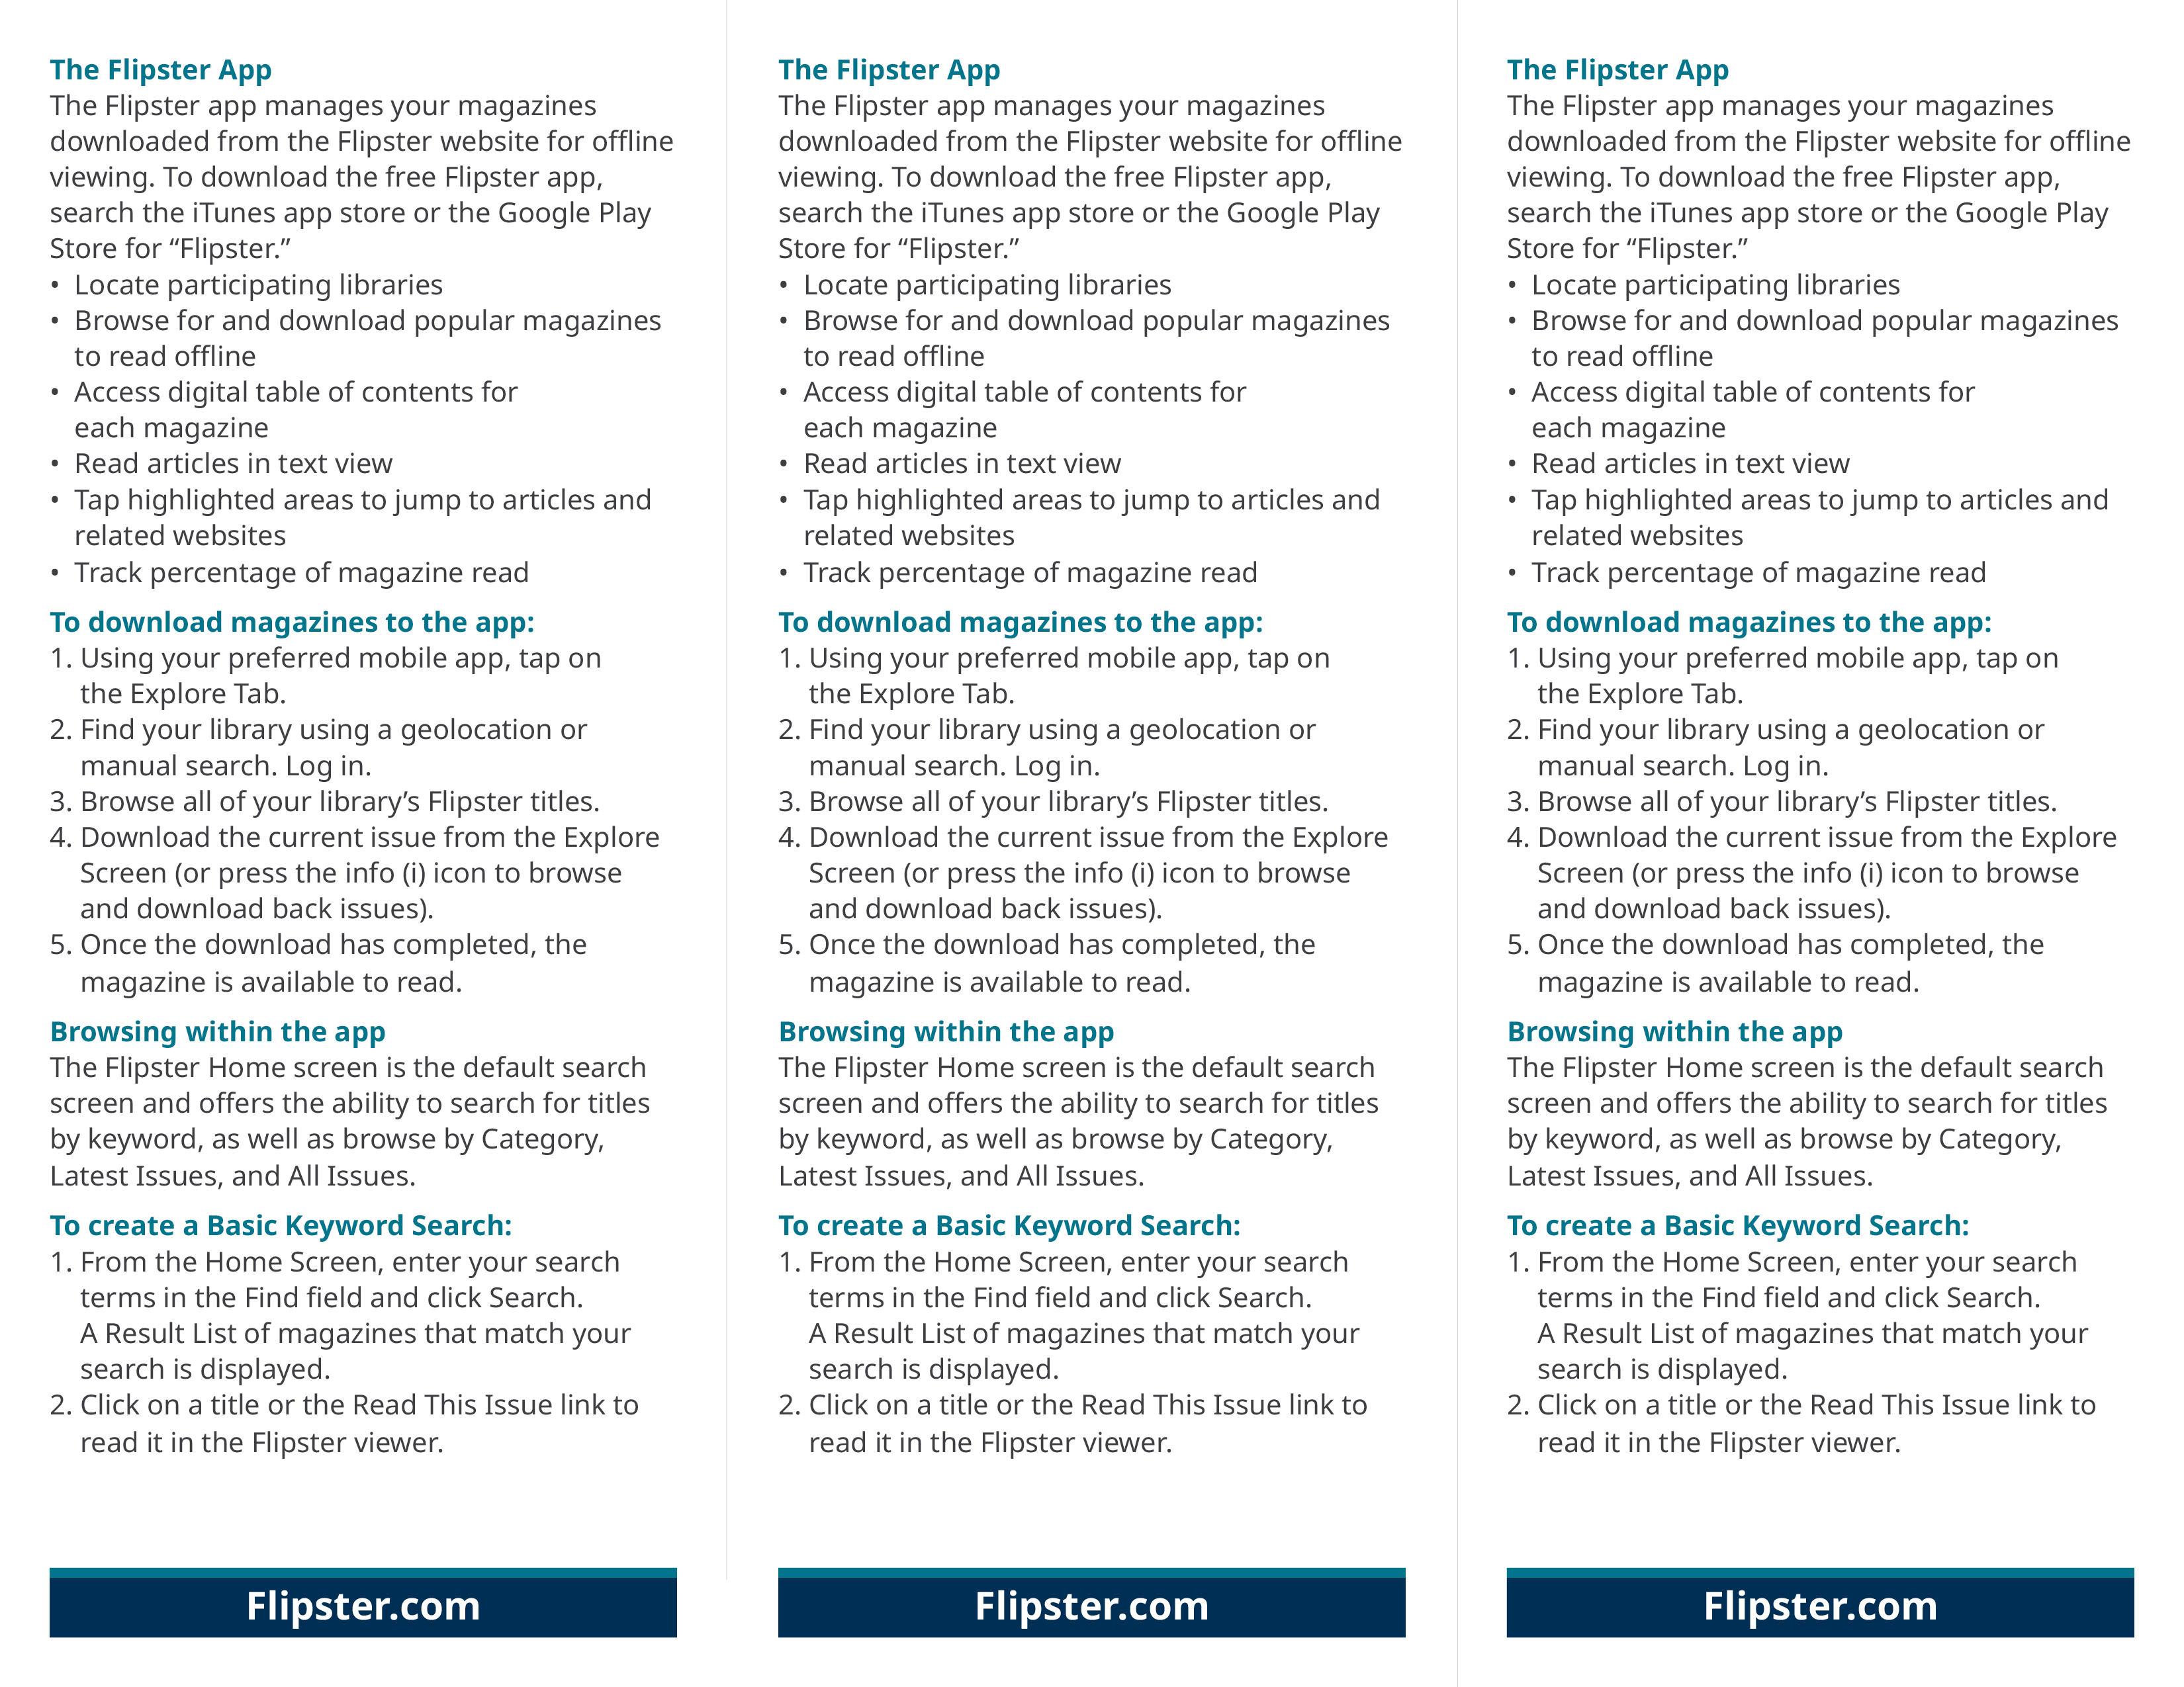
Insert Access URL/Logo here:
Insert Access URL/Logo here:
Insert Access URL/Logo here:

